David Chan

dc3808

N15400161

QGIS Lab 2

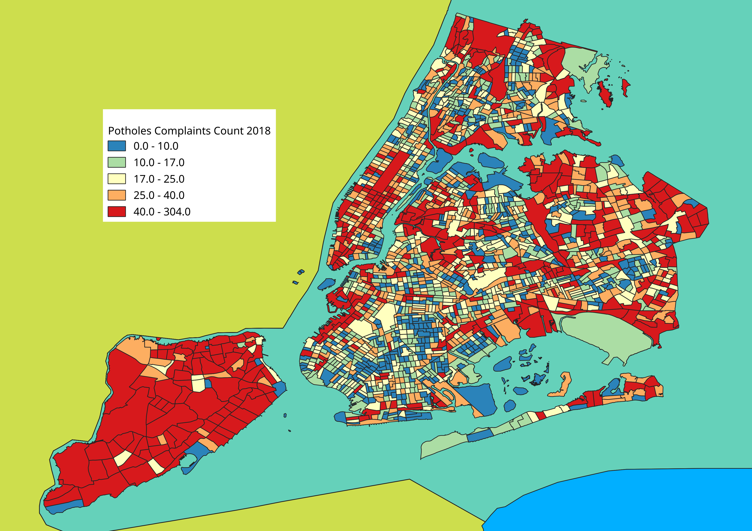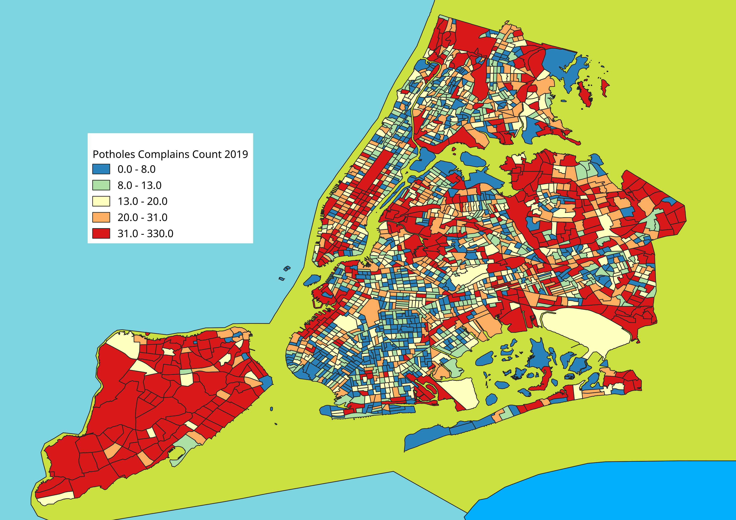

By comparing the two maps, I can see that there has not been much change between 2018 and 2019. The same zones have the most number of potholes complains, namely nearly all of Staten Island, midtown and downtown Manhattan, west coast of Brooklyn, etc. The most potholes complaints in 2018 and 2019 came from Charleston-Richmond Valley-Tottenville in Staten Island which is the Southern area in Staten Island. Areas with lower number of pothole complaints include most of Brooklyn such as East New York and Bay Ridge.

Some causes of potholes could be due to number of cars that pass by. In Staten Island, there is only 1 train. That means most people will travel by car or by bus. Roads in Staten Island are heavily used especially when a large number of people commute through Staten Island to go into New Jersey. Brooklyn, on the other hand, has lots of accessible trains Therefore, there will be less cars on the road. This theory is further proven by the number of complains we can see from the west border of Brooklyn. The west border of Brooklyn is the BQE highway where cars will be constantly traveling between Staten Island, Brooklyn, and Manhattan.